Debugging Questions-1

Name: N.ARUN KUMAR  
Reg.No: 192111266  
Subject: CSA0978 Programming in Java for web applications

1. AIM:

Program to return the square root of x rounded down to the nearest integer

PROGRAM:

import java.util.\*;

class Solution{

public static void main(String[] args) {

int x;

System.out.println("Enter number:");

Scanner sc=new Scanner(System.in);

x=sc.nextInt();

int sqrt = mySqrt(x);

System.out.println("Square root of " + x + " is " + sqrt);

}

public static int mySqrt(int x) {

if (x == 0) {

return 0;

}

int left = 1, right = x;

while (left <= right) {

int mid = left + (right - left) / 2;

if (mid == x / mid) {

return mid;

} else if (mid < x / mid) {

left = mid + 1;

} else {

right = mid - 1;

}

}

return right;

}

}

OUTPUT:

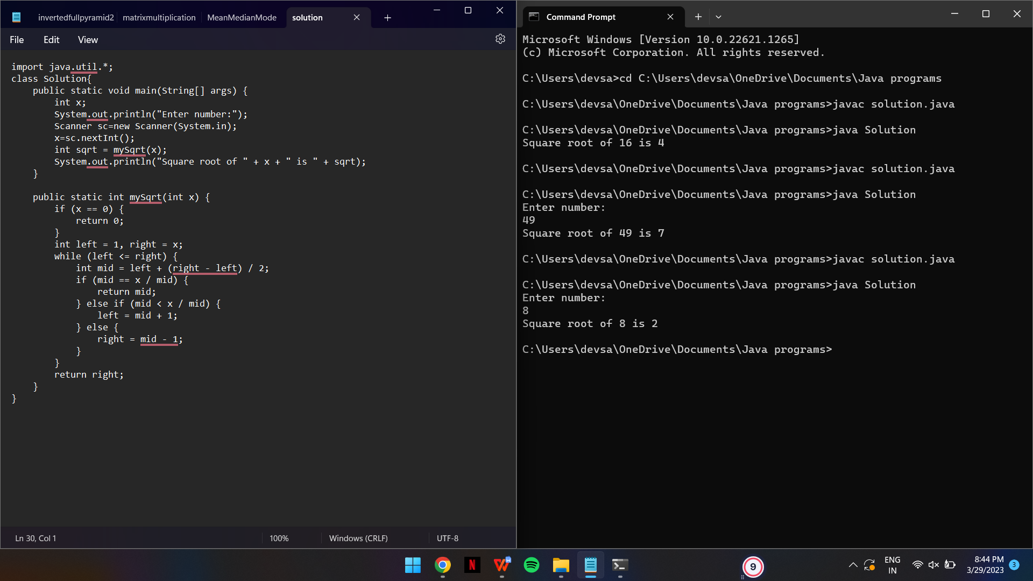

1. AIM:

To check for pallindrome or not

PROGRAM:

import java.util.\*;

class Solution1{

public static void main(String[] args) {

int x;

System.out.println("Enter number:");

Scanner sc=new Scanner(System.in);

x=sc.nextInt();

boolean isPalindrome = isPalindrome(x);

System.out.println(x + " is a palindrome: " + isPalindrome);

}

public static boolean isPalindrome(int x) {

if (x < 0) {

return false;

}

int reversed = 0, original = x;

while (x > 0) {

reversed = reversed \* 10 + x % 10;

x /= 10;

}

return original == reversed;

}

}

OUTPUT:

